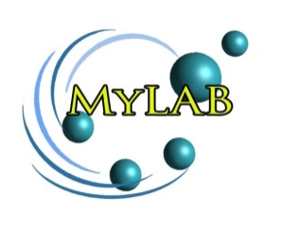
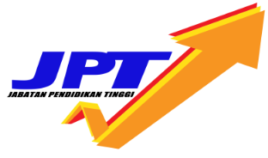

SEKSYEN B : MAKLUMAT PERMOHONAN PROJEK

[Incomplete Form will be rejected]
A. | Ringkasan Eksekutif / Executive summary:
Ringkasan Cadangan Eksekutif Projek (maksimum 600 patah perkataan)
(Meliputi pernyataan masalah, objektif, kaedah pembangunan produk, jangkaan hasil produk/ implikasi dan kepentingan output projek.
Executive Summary of Project Proposal (maximum 600 words)
Please include the problem statement, objectives, product development method, expected output/outcomes/implication, and significance of output from the project).

B. | Maklumat Ketua Penyelidik/ / Details of Project Leader:
(i) | Tarikh mula berkhidmat dengan Universiti ini:  Date of first appointment with this University:
(ii) | Bidang Kepakaran Dan Pengalaman Ketua Penyelidik:  Areas of Expertise and Experience Head of Research:
(iii) | Resume / CV Ketua Projek (lampirkan):  Resume / CV Project Leader (Please attach):
(iv) | Alamat Lengkap & Tempat projek dan Sub-Projek dijalankan: (senaraikan semua)  Complete address , Location of Project & Sub-Project on going : (List All)
(vi) | Ahli-ahli Ketua Sub-Projek: (Sila sertakan maksimum 5 halaman resume untuk setiap penyelidik)  Members of the Sub - Project Leader: (Please include maximum 5 pages of curriculum vitae for each researcher)
 | Bil. Nama Name No. Kad Pengenalan/ Pasport : IC / Passport No. Nama Universiti/ Industri : Name of University/Industry: Tahap Kelayakan Akademik/ Jawatan : Academic Qualification/ Designation : Tandatangan Signature
C. | Cadangan Maklumat Projek Secara Terperinci / Detailed Proposal of The Project
- Peranan Ahli Kolaborasi: Universiti Kolaborasi dan Industri
Role of member Collaborator: University and industry Collaboration
- Nama Universiti Kolaborasi (sila senaraikan)
Name of University Collaboration (List)

Bil. | Nama Universiti Kolaborasi / Industri  Name University Collaboration/ Industry | Peratusan Peranan (aktiviti)  Role percentage | Ringkasan peranan / Aktiviti Universiti Kolaborasi dan Industri  (di dalam projek MyLAB yang dipohon)  Summary of role / activity university collaboration and industry  (project in MyLAB been applied)

- Tempoh Projek dan Sub-Projek: Universiti kolaborasi dan Industri:
Duration of project and sub ​​projects : University and industry Collaboration

Bil. | Nama Universiti Kolaborasi / Industri  Name University Collaboration / Industry | Tempoh Sub-Projek di Universiti Kolaborasi / Industri  Duration Sub-Project at University Collaboration / Industry

 | - Perincian Industri Kolaborasi / Role of Industry Collaboration
- Senaraikan komitmen kewangan industri untuk aset atau bahan guna habis
(minimum 5% dari jumlah keseluruhan yang dipohon)
List of industrial financial commitment for asset or consumables
(minimum 5% from total amount applied)

- Senaraikan komitmen ‘in kind’ industri (sekiranya ada)
List of industrial ‘in kind’ commitment (if any)

- Jangkaan Harta Intelek Yang Akan Dibangunkan (senaraikan)
Expected Intellectual Property Development (list all)

